Model

*Model for transporter influence on product export*

**Introduction (Background)**

The accumulation of certain terpenes, including sesquiterpenes and triterpenes which host members we are interested in, within yeast cells could potentially be toxic to them, leading to reduction in yeast growth and production of compounds of interest (L, 2023)..

For example, β-farnesene is said to have negative impact on the cell which causes slow growth, complex growth medium requirements, and product cytotoxicity (Mai, 2021). ??? [More details on mechanism. Look for evidence of what some terpenes do within yeast cells.]

It is expected that transporting those products to the culture media outside of the cell could lower the impact of intracellular metabolite toxicity on cellular growth. Hence, we aim to explore if engineering terpene exporting transporters could improve cell growth and production of metabolites of interest through *in silico* modeling and simulation. In addition, we aim to compare the efficacy of different transporters. .

Through literature mining, we chose the Multi drug and Toxic compound Extruction Transporters (MATEs) , which is proven to be essential for the terpenoid export in plant, to export santalol (Yazaki et al., 2007). We assumed that MATEs could export terpenoids in yeast cells at similar efficiency as in plant cells.

**Modeling Process**

Firstly, the regular logistic growth and the rate of change of yeast population with time (without toxicity created by metabolites is modelled using the differentiation equation below utilizing intrinsic growth rate (r), current yeast population (P), and carrying capacity (C):

Next, the basic rate of metabolite production in respect to time (is modelled using the metabolite production rate (k) and the population:

Due to the intracellular toxicity from metabolites (concentration modelled by M) produced, the effect of toxicity (d) needs to be taken into account when modelling the population change of yeast forming the equation:

In order to increase overall production of metabolites, an exportation of metabolites using transporters to maintain yeast population is modelled. The amount of santalol (M) exported from membrane transporters per unit time (written as ) is modelled using the Michaelis Menten equation :

(maximum rate of metabolite transport) and (concetration of metabolite at half-maximal transport rate) are defined as the kinetics of the sesquiterpene transporter utilized in the model.

Finally, the total amount of metabolites in the cell, the original amount produced by yeast in addition to the regression of metabolite concentration from metabolite exportation by transporters, is written as:

*Results*

*Experiment 1: hOCT2 transporter effect on Population Growth Rate and Metabolite Concentration*

The kinetics of interaction of hOCT2 with PQ was saturable with

a *K*m value of 114± 23 µM and *a V*max value of 174 ± 37 pmol/mg/min

We used the ODE solver “deSolve” in R Studio to........................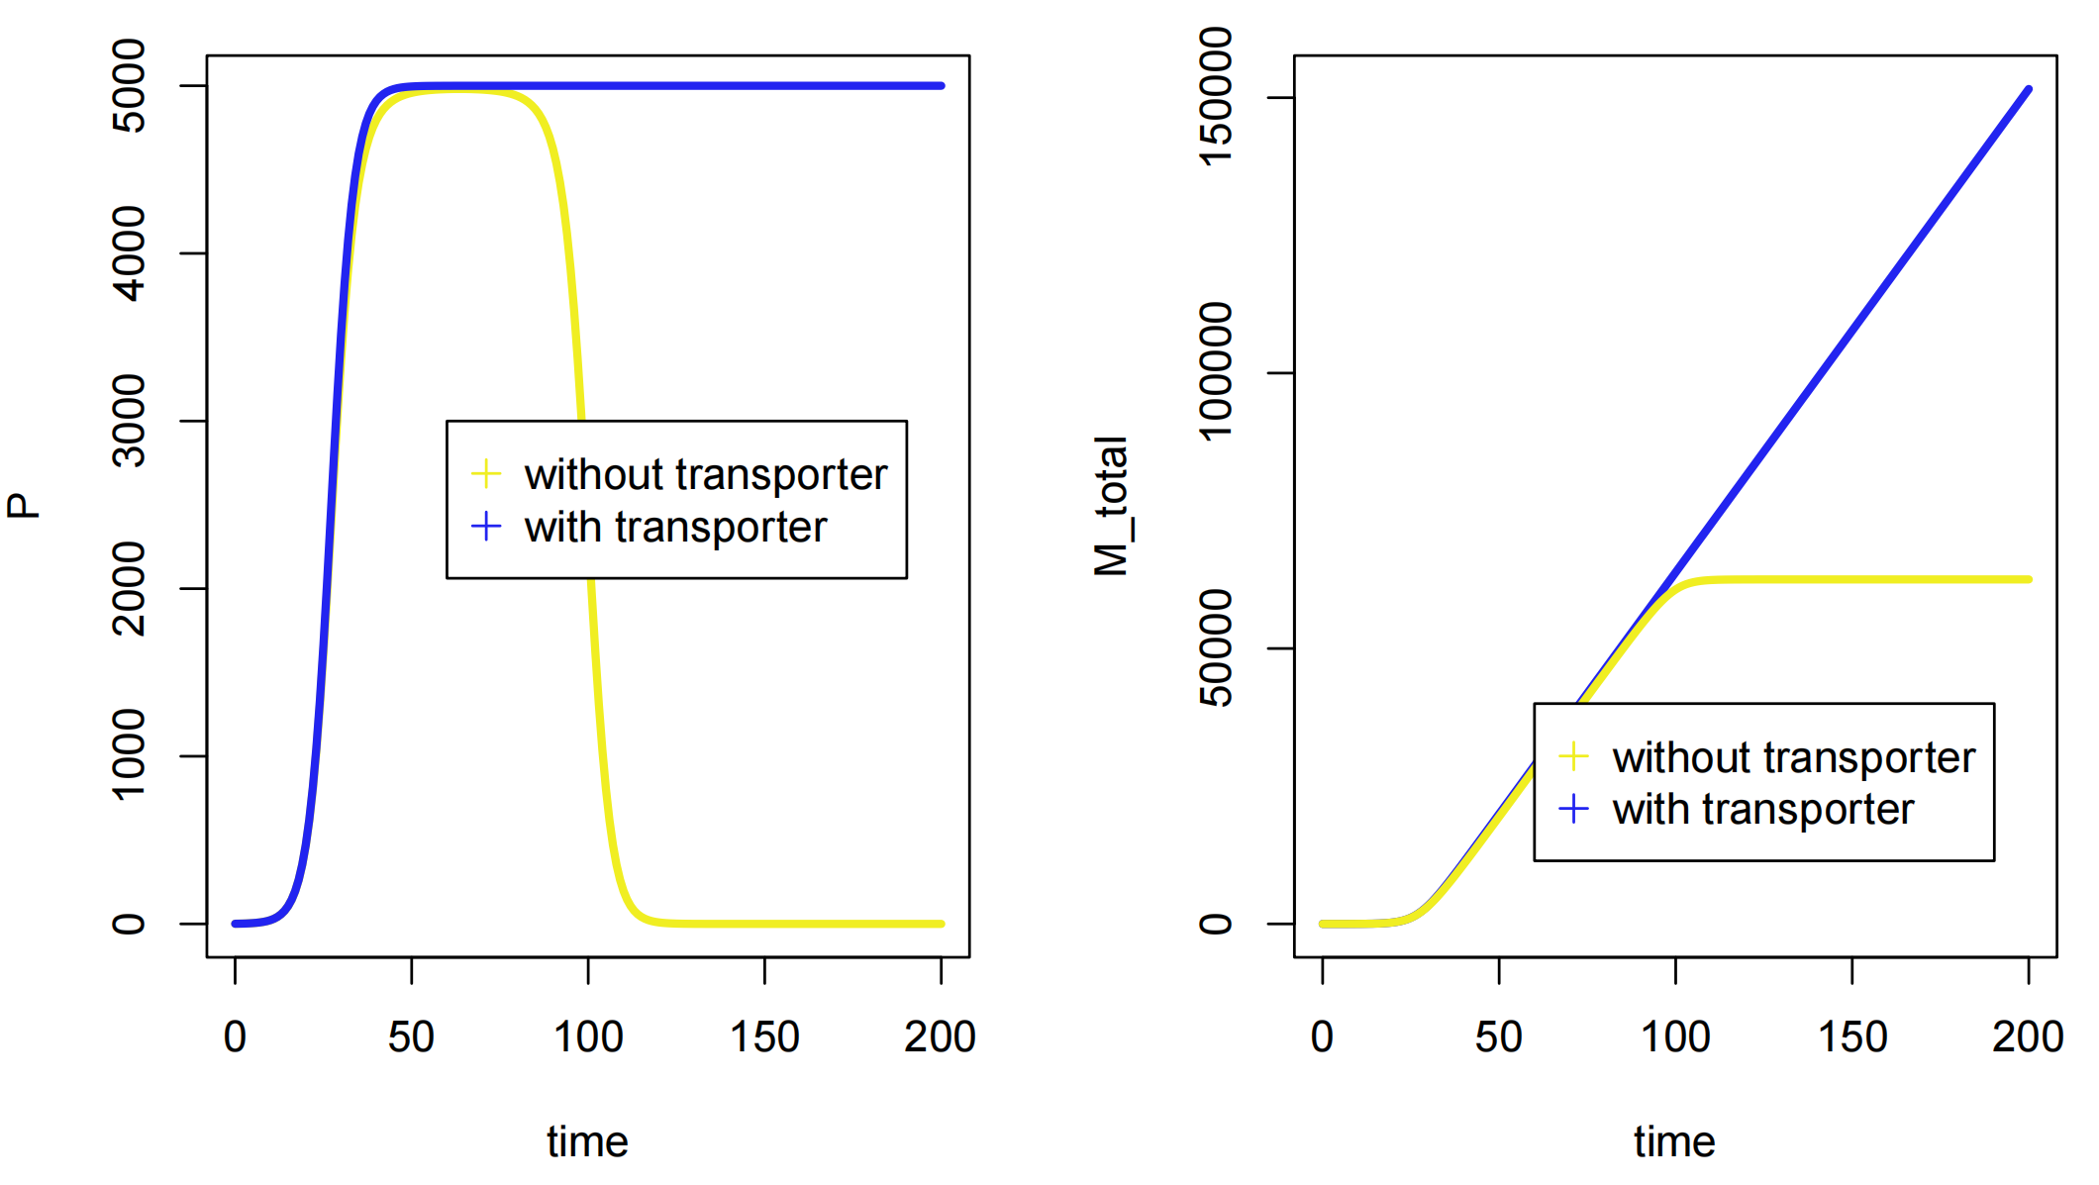

As shown in the population/time graph (left), the amount of S.cerevisiae without transporter reaches the peak at approximately the 45th hour and starts to decrease at about the 90th hour. In comparison the graph showing the amount of S.cerevisiae with transporter starts to increase at the same time but remains at the population of approximately 5000.

In the metabolite concentration/time graph (right), the total amount of metabolites produced in S.cerevisiae without transporters stops producing metabolites at about the 100th hour, while the S.cerevisiae with transporters continues to produce metabolites with a steady rate.

Experiment 2: rMATE1 transporter effect on Population Growth Rate and Metabolite Concentration

XXXXXXXXXXXXX

**Discussion**

As seen in the results, our model shows that with an suitable ABC transporter used, the sencondary metabolites could be exported and the cytotoxity could be lowered. XXXXXXXXXXXXXXXXXXXX

Chen, L., Xiao, W., Yao, M., Wang, Y., & Yang, Y. (2023). Compartmentalization engineering of yeasts to overcome precursor limitations and cytotoxicity in terpenoid production. Frontiers in Bioengineering and Biotechnology, 11. https://doi.org/10.3389/fbioe.2023.1132244

Mai, J., Li, W., Ledesma-Amaro, R., & Ji, X. (2021). Engineering Plant Sesquiterpene Synthesis into Yeasts: A Review. Journal of Agricultural and Food Chemistry, 69(33), 9498–9510. https://doi.org/10.1021/acs.jafc.1c03864

Yazaki, K., Sugiyama, A., Morita, M., & Shitan, N. (2007). Secondary transport as an efficient membrane transport mechanism for plant secondary metabolites. *Phytochemistry Reviews*, *7*(3), 513–524. https://doi.org/10.1007/s11101-007-9079-8

‌

‌